**Lesson 4 Demo 16**

**Understanding Manifest Management and Common Templating Tools**



Steps to be followed:

1. Installing Helm
2. Searching for publicly available charts
3. Creating a sample template

**Step 1: Installing Helm**

* 1. Install helm by executing the following command:

***sudo snap install helm --classic* **

* 1. Verify the installation by executing:

***helm version***



**Step 2: Searching for publicly available charts**

1. Execute the following command to search for publicly available charts:

**sudo helm search hub twitter**

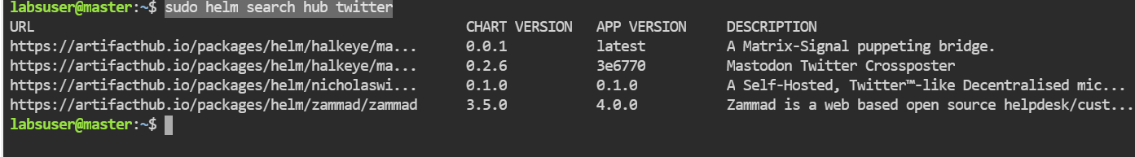

**Step 3: Creating a sample template**

* 1. To create a testchart enter the following command:

**helm create testchart**



* 1. Go to the directory named testchart:

***cd testchart***

* 1. List the files in testchart directory:

**ls**



* 1. Go to templates directory and charts directory, and browse the content:

***cd templates***

***ls***

